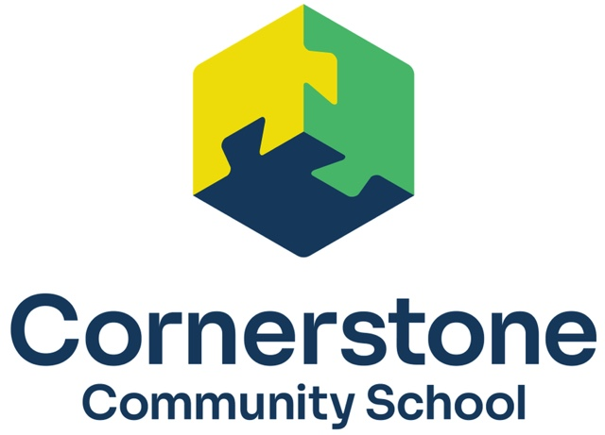
6.1 Dress Code

We believe that Christ should be honored and respected by our appearance. With this in mind, we have established the following standards for dress and appearance for our school that will promote modesty, unity, and neatness:
Pants
Pants must be black, navy, or khaki uniform style. Jogger and jegging fits are acceptable if they have pockets and/or a zipper. Plain leggings may only be worn under dresses or skirts. Cargo pockets are not acceptable.
Skirts, Skorts, Shorts
Skirts, skorts, or shorts must be black, navy blue, or khaki. Uniform style, no cargo pockets. Length must be appropriate for school. Shorts may only be worn during the first and fourth grading periods. If girls choose to wear skirts or skorts during the 2nd or 3rd quarter, they must wear plain tights or leggings to cover and protect their legs.
Jumpers/Collared Polo Dresses
Navy blue, light blue, red, or khaki. Length must be appropriate for school. Plain tights or leggings may be worn to cover and protect their legs. Tights or leggings are required in the 2nd and 3rd quarter when wearing jumpers or dresses.
Shirts
Black, red, white, light blue or navy blue. Collars required--polo style, Oxford type or turtleneck are all acceptable. No visible logo, other than the CCS logo, is to appear on shirts. Students are to present themselves in a neat and tidy fashion. T-shirts and long sleeve shirts worn under uniform shirts must be white, red, navy blue, or light blue. Red will no longer be part of the school dress after the 2023-2024 school year.
Sweaters and Sweater Vests
Red, white, light blue or navy blue. Cardigans, pullovers and vests may be worn over a collared shirt. Hoods are not permitted.
CCS Logo Shirts and Sweatshirts
New students all receive a CCS polo shirt once they are enrolled. Only plain sweatshirts or those with the CCS logo can be worn during the school day. A shirt or turtleneck must be worn underneath the sweatshirt. Hoods are not permitted.
Socks
Knee-high socks must be solid white, blue, red, gray, khaki, or black. The color of socks that are mid-calf or lower is not a concern.
Tights/Leggings
Tights or leggings are not uniform pants. They may be worn under skirts or skorts. They must be solid white, blue, red, gray, khaki, or black.
Shoes
Dress shoes or tennis shoes are acceptable. Tennis shoes are required on P.E. days. Laced shoes must be laced at all times. Heels may not be higher than 1”. No lights, platforms, wheeled, or noise-making shoes. All shoes must have non-marking soles. Sandals are not permitted. Boots are necessary as outerwear during snowy and wet weather.

Belts
Solid colors. No patterned or ornamental belts are allowed. Braided leather belts are acceptable.
Grooming
Hair should be clean, neat and not in the eyes or face. Hair must remain a natural color and not be a distraction for others.
Make-up
No make-up should be worn.
Jewelry
Limited to one pair of small earrings, one necklace, one bracelet and one ring on each hand. Boys may not wear earrings. Smart watches with communication capabilities are not allowed during the school day. They must remain in their lockers during the day, but they may not be accessed during school hours or during school functions.
Hats and Coats
Coats and accessories appropriate to the weather are expected since the children play outside throughout the school year. During the winter months, girls who are wearing skirts, jumpers or skorts may keep sweats or other warm pants at school for use during recess. Snow suits and/or warm clothing are expected to be available and worn during the winter months. Hats and scarves may not be worn to class.
If a student is not dressed according to the CCS Dress Code, parents will receive notification detailing what the infraction was and how to correct it. Final decisions regarding dress code will be left to administration.

Rev 6/22/23

